**High Bias:**

High Bias model(given low variance) means model is underfitting i.e model is too simple and does not capture complexity of data. so high error on both train and test data.

Therefore if we have high train error then it’s bias is also high.

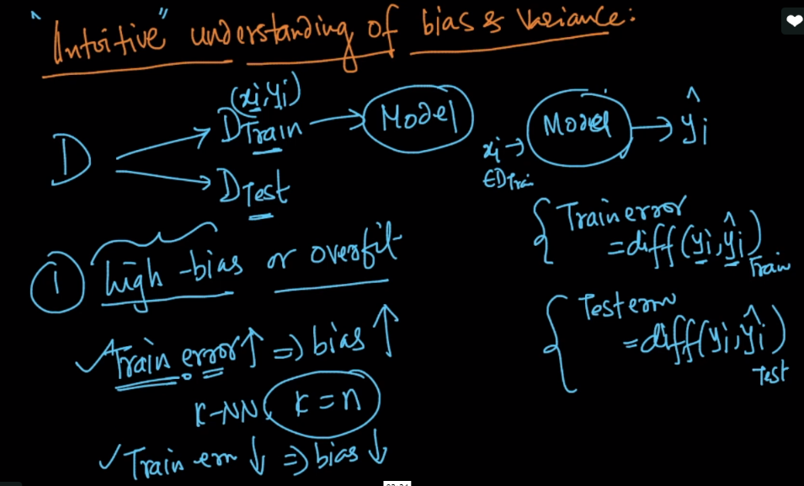

**High Variance or overfitting:**

High Variance(given low Bias) means model is overfitting i.e model is flexible and tune itself to all data points in training data and when different data point occcurs in testing phase then it can't make right prediction. so performs well on train data but has high error rates on test data.

Whenever there is low train error and very high test error then such have high variance or model is overfitted.

Therefore we can say that for k=1, K-NN will have high variance, as for any point difference there will be huge changes in model prediction.

